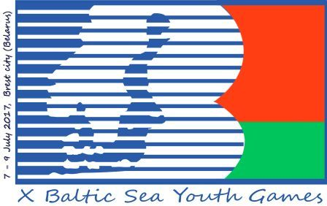 | X Baltic Sea Youth Games  7-9 July 2017, Brest city (Belarus) | Ministry of Sports and Tourism  of the Republic of Belarus  8/2 Kirova Str.,  Minsk, Republic of Belarus, 220050  Tel. +375 17 3278966  Tel. +375 17 3271734  Tel. +375 17 3277734  http://www.mst.by  Email: xbsyg2017@tut.by

Country: LATVIA

Kind of sports: athletics
№ | Surname,  first name | Sex | Sports event,  weight class
Athletes
1 | Edvīns Hadakovs | m | 80 mH, Long Jump, 4x100
2 | Elvis Veinbergs | m | Long Jump, 100m, 4x100m
3 | Raivo Liniņš | m | 3000 m track walk
4 | Ralfs Strioga | m | 80 mH, High Jump
5 | Markuss Ozols | m | 800 m
6 | Matīss Gržibovskis | m | 300 m, 4x100m
7 | Jegors Gerasimovs | m | 100 m, high jump, 4x100m
8 | Artjoms Sitņuks | m | 3000 m
1 | Daniela Supe | w | 100 m, 80 m/H, 4x100m
2 | Kamilla Vanadziņa | w | 3000 m
3 | Elva Vestarta | w | Hammer Throw, Shot Put
4 | Sonora Sergejeva | w | 100 m, Long Jump, 4x100m
5 | Klinta Lindāne | w | 300 m, 4x100m
6 | Elīna Tumša | w | HJ, 4x100m
7 | Katrīna Nikola Jukšinska | w | Javelin throw
8 | Annika Upīte | w | Javelin throw
Leaders, coaches, referees, support stuff, drivers
№ | Surname,  first name | Sex | Function
1 | Anita Klapote | w | coach
2 | Imants Roziņš | m | coach
3 | Ainis Raubišķis | m | coach
4 | Baiba Kaufmane | w | coach
5 | Dmitrijs Hadakovs | m | coach

